2020

**Submitted By:**

**Manmeet Singh**

Project Report

**Contents**

**Project Proposal** 2

**Goals and Objectives** 2

**Scope and Deliverables** 2

**Project Scope** 2

**Project Deliverables** 2

**Project Specification and Target Audience** 2

**Project Schedule and milestones** 3

**Resources Required** 3

**Functional and Non-Functional Requirement** 3

**Functional Requirements** 3

**Non-Functional Requirements** 4

**Project Assumptions** 4

**Detailed Design** 4

**Home Page** 4

**Login Page** 5

**New Admin Registration Page** 5

**Admin Service Booking Page** 6

**Admin Vehicle Service Page** 6

**Admin Vehicle Owner Page** 7

**Vehicle Owner Service Offered Page** 8

**Vehicle Owner Service Booking Page** 8

**Vehicle Owner Details Page** 9

**Vehicle Owner Signup Page** 9

**Project Testing** 10

**User Manual** 10

**User Activities** 10

**Admin Activities** 10

# **Project Proposal**

## **Goals and Objectives**

The main goal of this project is to build an online web application named “Vehicle Service”. In this application there are two types of users. Admin and Vehicle Owner. The rights of admin and vehicle owners vary. Admin can add, delete, update, view vehicle services details. Admin can also delete and check details of service bookings. Admin can also edit, delete, and check details of the vehicle owners. Admin can register new admins. Moreover, vehicle owners can view service details and create bookings. Vehicle owners can also access details of service booking and can delete the service bookings. New vehicle owners can register with the application for free.

## **Scope and Deliverables**

## **Project Scope**

The duration for the project was 4 weeks i.e 20 days approximately. The scope of the project is to implement the admin functionality such as add, update, delete. For vehicle owners to implement the functionality of viewing the service details, create a booking, delete service booking and check details for the same.

## **Project Deliverables**

To achieve the goal of our project, we have set the following deliverables:

|  |  |
| --- | --- |
| **Deliverables** | **Explanation** |
| Project Planning | It includes project planning and design. |
| Design | It includes the front end design for the web application |
| Coding | This includes the coding part of the project. |
| Implementation and Testing | Demonstration of how application it will be used and also the test details of the web app. |
| Final Documentation | It includes the final documentation for the project. |

## **Project Specification and Target Audience**

* Login and logout should be secure for both admin and vehicle owners.
* Add, update, delete, and view details of service details for admin.

Service booking delete and check details for admin.

* Edit, delete, and check details of Vehicle Owner for admin.
* Vehicle owners can view and create a booking for the vehicle service.
* Vehicle owners can also delete and check details for service booking.

Moreover, the Target audience for this web application will be the people who have cars and can get a service for their vehicles.

# **Project Schedule and milestones**

|  |  |  |
| --- | --- | --- |
| Phases/ Milestones | Time Frame in Weeks | Deliverable(s) Completed |
| Project Scheduling | 1-2 | * Initial Meeting * Requirement Analysis Report * Project Proposal documentation |
| Phase 1 | 2-3 | * Database Design and front end design |
| Phase 2 | 3-4 | * Front and Back End implementation of Final App |
| Phase 3 | 3-4 | * Testing of the project and Final Report |

# **Resources Required**

Following are the resources required to complete this project:

* Minimum i5 processor with 4-8 GB of RAM
* MS Word, Excel
* ASP.Net MVC and Identity Framework
* Windows OS 10

# **Functional and Non-Functional Requirement**

The functional and non-functional requirements for the project are as below:

## **Functional Requirements**

* The application should allow a new user to register.
* Existing users can login and view the vehicle services and can create a booking.
* Admin can manage the vehicle services, service booking, and vehicle owners for the application.

## **Non-Functional Requirements**

* Fast Loading speed of the application.
* Multiple browser and device support.
* Usability and accessibility of the application..

## **Project Assumptions**

Following are the assumptions which I made while developing this project:

* Minimum One user and admin will be registered with the application.
* Anyone can register with the application for free.
* Initially one admin will be there and later more than one admin can be created.

# **Detailed Design**

## **Home Page**

This is the main page of the web application. All users can view this page of the application even without login. This page contains home, Our Services, Service Booking, Vehicle Owner Sign up, Login, ass New Vehicle Admin menu options on the navigation bar. Also, in the header image there is a button called view services.

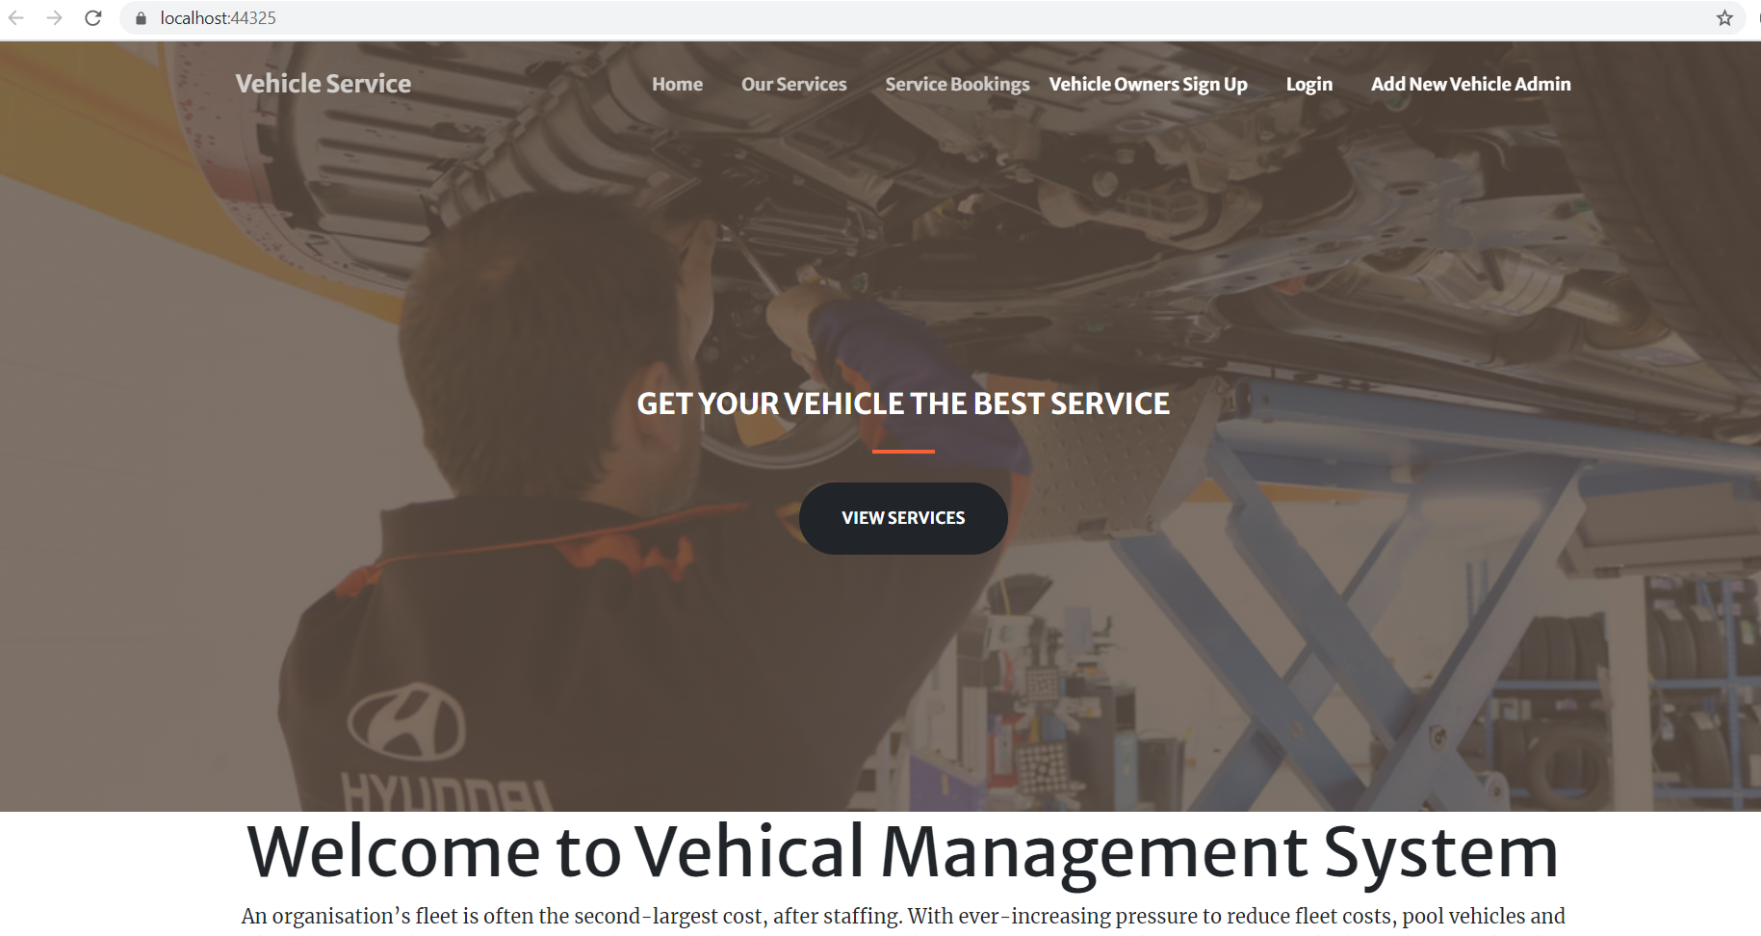

## **Login Page**

This Page of the application will be used by the vehicle owner and admin to login into the system. It is common to admin and vehicle owners. They need to use their credentials.

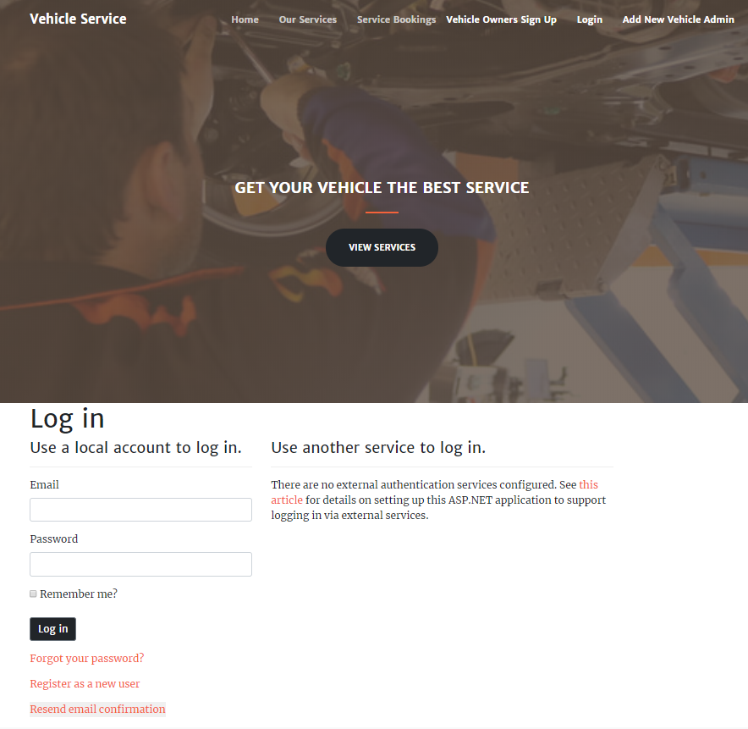

## **New Admin Registration Page**

With the help of this page admin can register new admins for the sight.

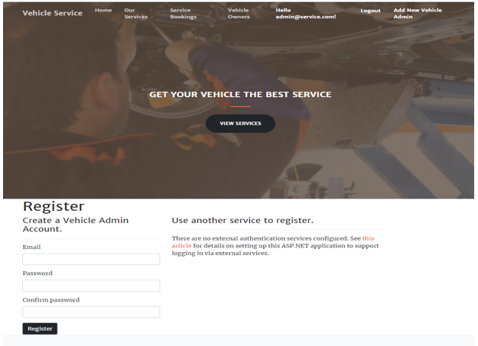

## **Admin Service Booking Page**

This page provides the information about the service booking. Admin can delete and view the details of the service bookings.

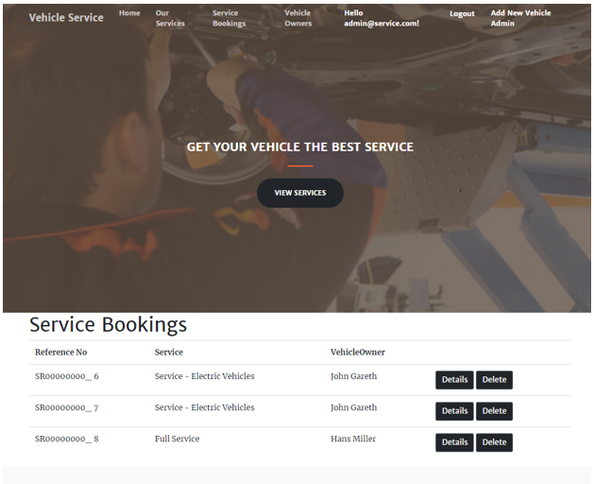

## **Admin Vehicle Service Page**

In this page admin can add, update, delete, and view details of the services offered.

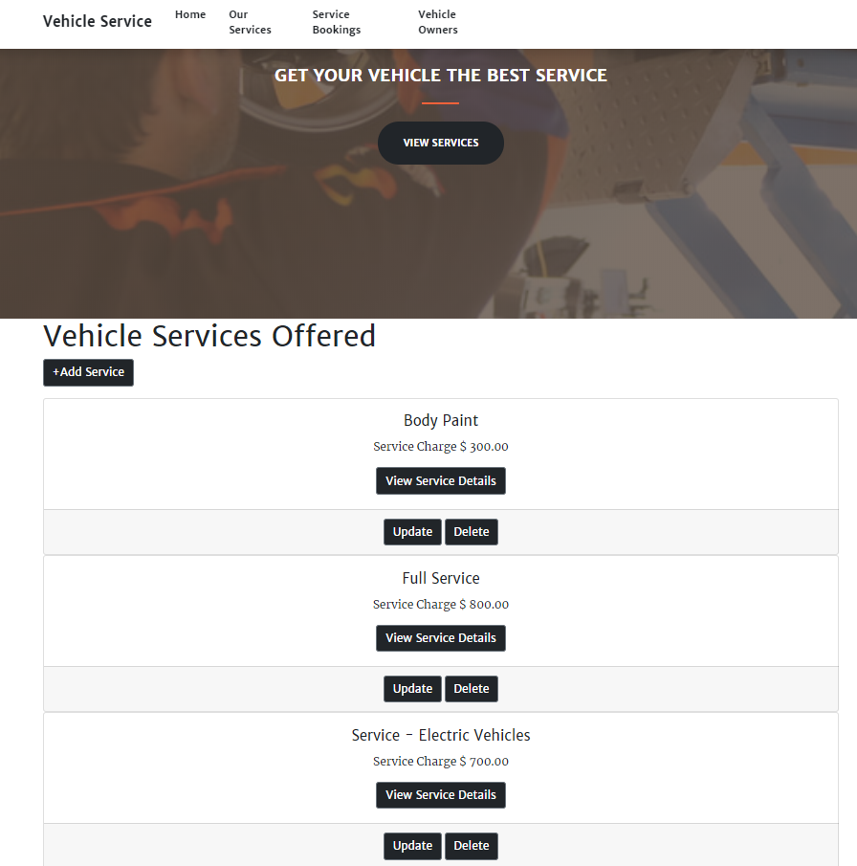

## **Admin Vehicle Owner Page**

With the help of this page, admin can edit, delete, and check details of the vehicle owners.

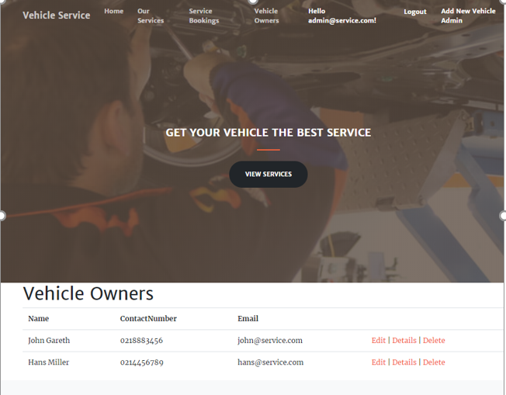

## **Vehicle Owner Service Offered Page**

In this page vehicle owner can view all service details offered.

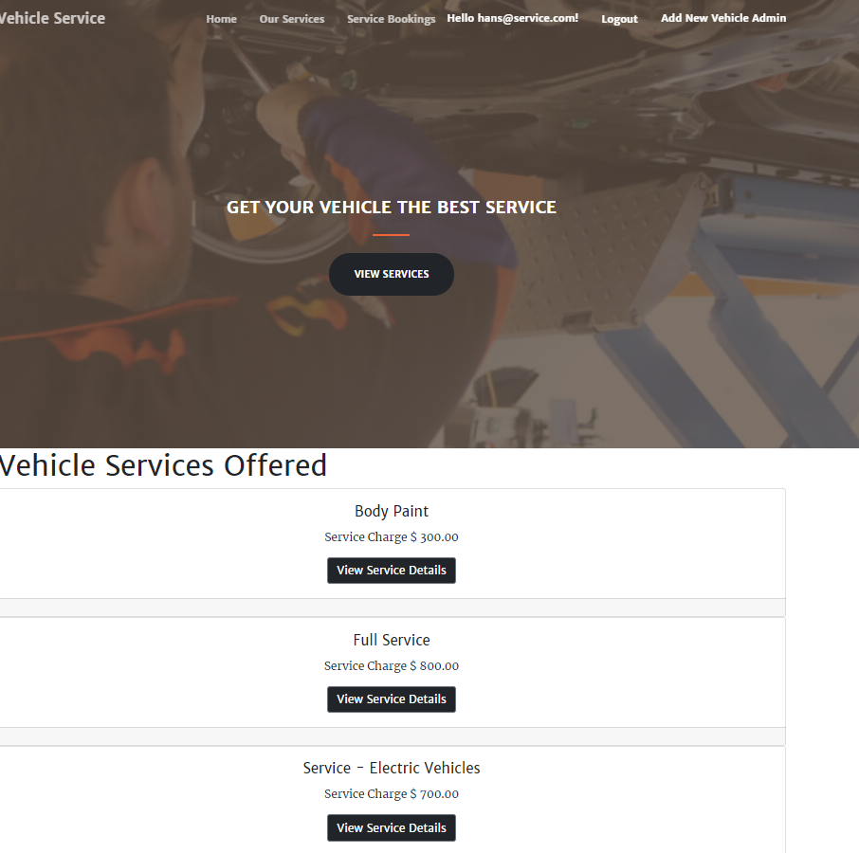

## **Vehicle Owner Service Booking Page**

With the help of this page vehicle owners can access the details of service bookings and can also delete the service bookings.

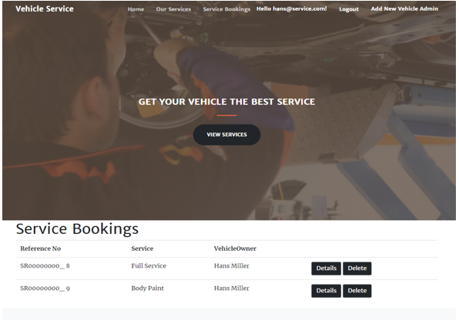

## **Vehicle Owner Details Page**

With the help of this page, the vehicle owner can view the details of the services offered and can create a booking for the same.

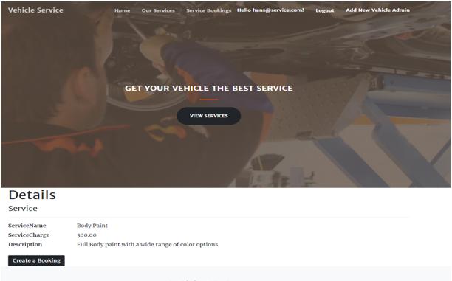

## **Vehicle Owner Signup Page**

New vehicle owners can signup with the help of this page.

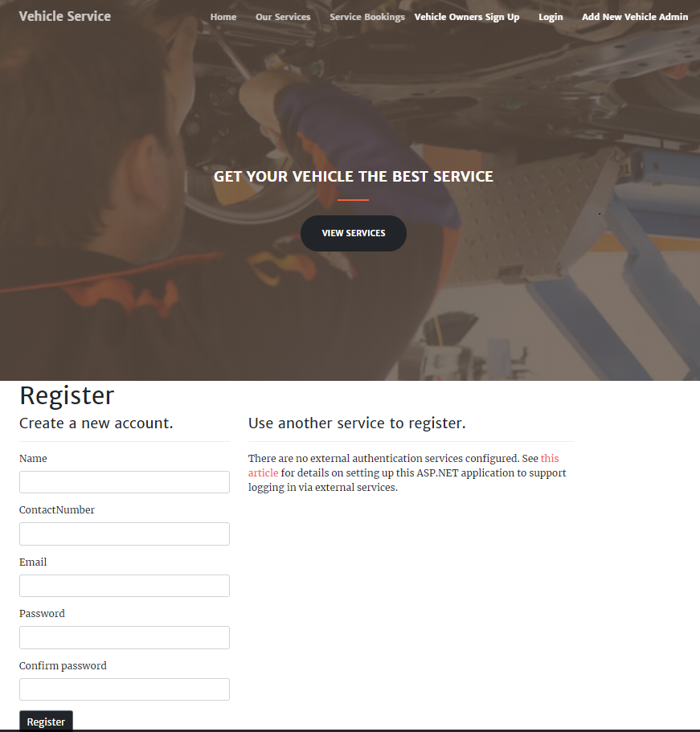

# **Project Testing**

Due to the limited time for the project, only the main features of the web application are tested in the form of usability testing. The usability testing of the report can be found at [Usability Testing.xls](Usability%20Testing.xls)

# **User Manual**

In the “Vehicle Service” application there are two types of users. Admin and Vehicle Owner. The rights of admin and vehicle owners vary. Admin can add, delete, update, view vehicle services details. Admin can also delete and check details of service bookings. Admin can also edit, delete, and check details of the vehicle owners. Admin can register new admins. Moreover, vehicle owners can view service details and create bookings. Vehicle owners can also access details of service booking and can delete the service bookings. New vehicle owners can register with the application for free.

## **User Activities**

* User Registration
* Login/Logout
* View Service Details
* Create a Booking
* Delete and check details for service bookings

## **Admin Activities**

* New Admin registration
* Login/Logout
* Add, update, delete, check details for the vehicle services
* Delete and details Check for Service Bookings
* Edit, delete and detail check for Vehicle Owners